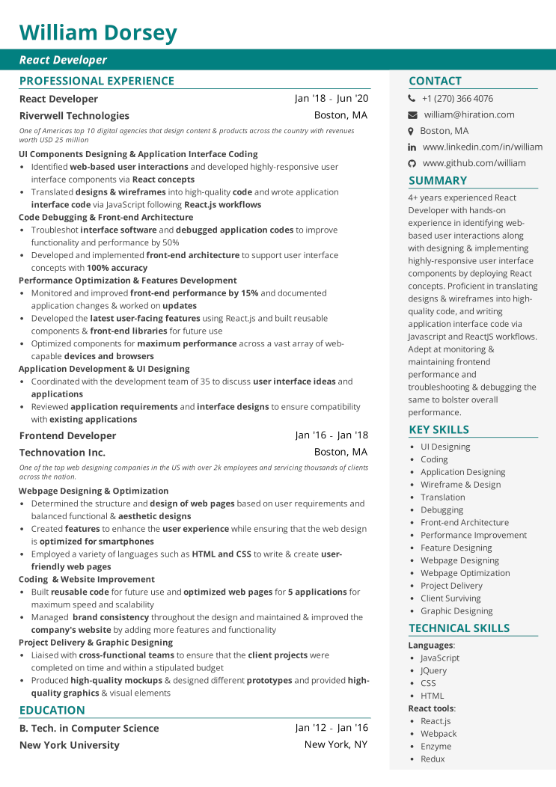
William Dorsey
React Developer
PROFESSIONAL EXPERIENCE
React Developer
Riverwell Technologies
Jan '18 - Jun '20
Boston, MA
One of Americas top 10 digital agencies that design content & products across the country with revenues worth USD 25 million
UI Components Designing & Application Interface Coding
• Identified web-based user interactions and developed highly-responsive user interface components via React concepts
• Translated designs & wireframes into high-quality code and wrote application interface code via JavaScript following React.js workflows
Code Debugging & Front-end Architecture
• Troubleshot interface software and debugged application codes to improve functionality and performance by 50%
• Developed and implemented front-end architecture to support user interface concepts with 100% accuracy
Performance Optimization & Features Development
• Monitored and improved front-end performance by 15% and documented application changes & worked on updates
• Developed the latest user-facing features using React.js and built reusable components & front-end libraries for future use
• Optimized components for maximum performance across a vast array of web- capable devices and browsers
Application Development & UI Designing
• Coordinated with the development team of 35 to discuss user interface ideas and applications
Reviewed application requirements and interface designs to ensure compatibility with existing applications
Frontend Developer
Technovation Inc.
CONTACT
+1 (270) 366 4076
william@hiration.com
Boston, MA
in www.linkedin.com/in/william
www.github.com/william
SUMMARY
4+ years experienced React Developer with hands-on experience in identifying web- based user interactions along with designing & implementing highly-responsive user interface components by deploying React concepts. Proficient in translating designs & wireframes into high- quality code, and writing application interface code via Javascript and ReactJS workflows. Adept at monitoring & maintaining frontend performance and
troubleshooting & debugging the same to bolster overall performance.
KEY SKILLS
Jan '16 - Jan '18 Boston, MA
• UI Designing
• Coding
One of the top web designing companies in the US with over 2k employees and servicing thousands of clients across the nation.
Webpage Designing & Optimization
• Determined the structure and design of web pages based on user requirements and balanced functional & aesthetic designs
• Created features to enhance the user experience while ensuring that the web design is optimized for smartphones
• Employed a variety of languages such as HTML and CSS to write & create user- friendly web pages
Coding & Website Improvement
• Built reusable code for future use and optimized web pages for 5 applications for maximum speed and scalability
• Managed brand consistency throughout the design and maintained & improved the company's website by adding more features and functionality
Project Delivery & Graphic Designing
• Liaised with cross-functional teams to ensure that the client projects were
completed on time and within a stipulated budget
• Produced high-quality mockups & designed different prototypes and provided high- quality graphics & visual elements
EDUCATION
B. Tech. in Computer Science
New York University
Jan '12 - Jan '16
New York, NY
• Application Designing
• Wireframe & Design
• Translation
•
Debugging
• Front-end Architecture
·
Performance Improvement
• Feature Designing
• Webpage Designing
• Webpage Optimization
• Project Delivery
• Client Surviving
• Graphic Designing
TECHNICAL SKILLS
Languages:
• JavaScript
• JQuery • CSS
• HTML React tools: • React.js • Webpack
• Enzyme
• Redux

